**JAVA STRING**

**String in Java**

* Is an object.
* Array of characters.

**Char Array to String Conversion**



**Basic String Operations**

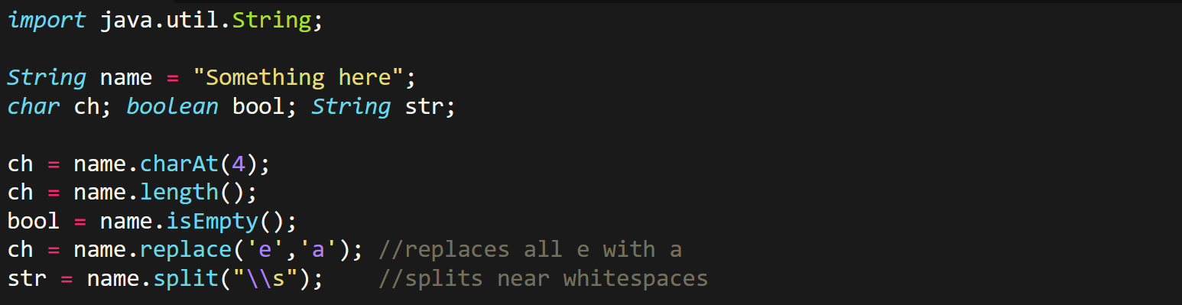

**String Comparison**

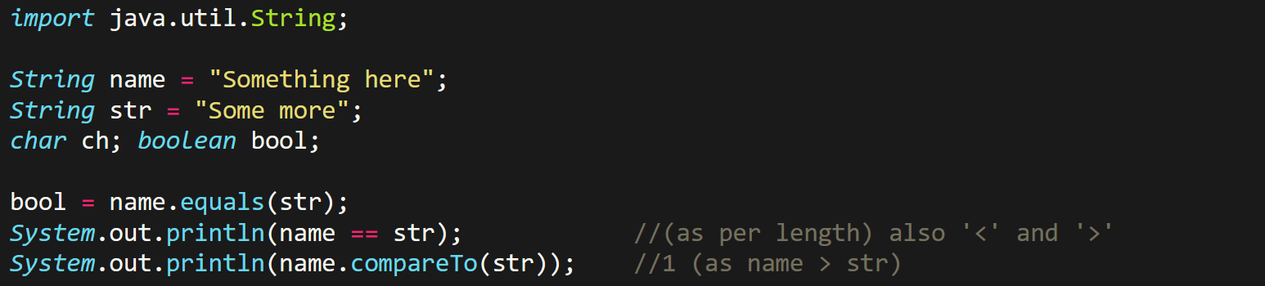

**String Concatenation**

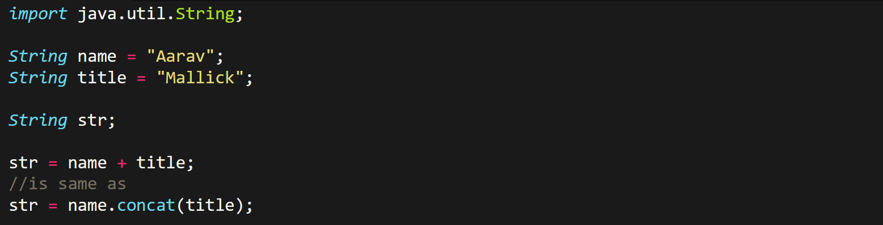

**Reversing String**

